VEMI Biosynchronizer Pilot Study – Simplified Report

Introduction
This study examined the effects of the VEMI Biosynchronizer over a three-week period:
- Day 1: Participants were assessed before and after one session.
- Following Weeks: Participants attended three sessions per week for three weeks.
- Final Day of Intervention: Assessments were conducted before and after the session on the last day.
The study involved 10 participants. The assessments used heart rate variability (HRV), bioimpedance, and far-infrared spectroscopy devices from Biotekna, Italy.

The study was conducted under the supervision of Dr. Francisco Cidral ND PhD (Scientifica Consulting).

Main Outcomes:
Mean Heart Rate (HR)
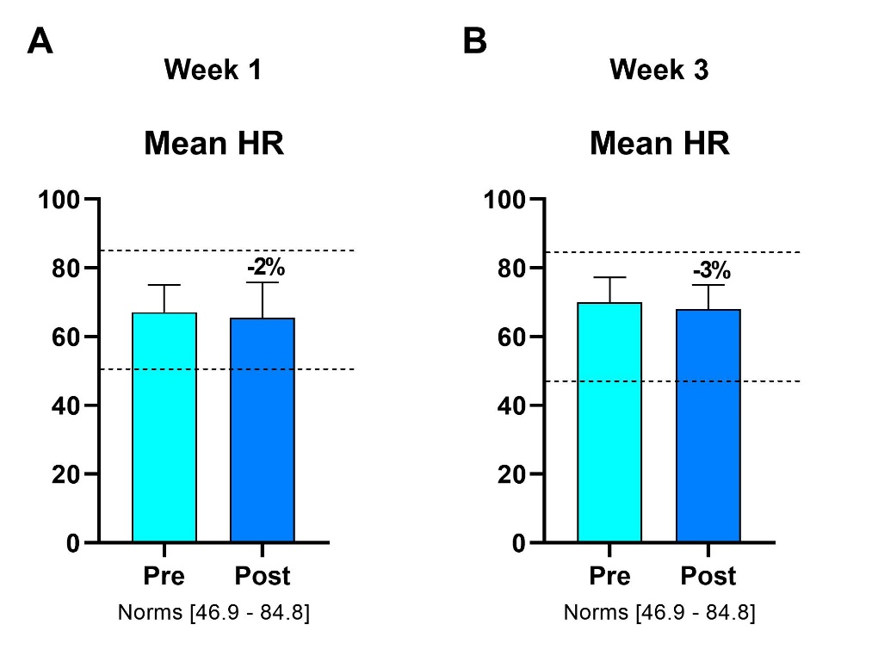

Mean Heart Rate (HR) reflects the average number of heartbeats per minute. A higher mean HR is associated with increased activation of the sympathetic nervous system, which controls the body's stress responses.
The data from the study showing a 2% reduction in mean HR after 30 minutes of therapy in the first week, followed by a 3% reduction in the third week, suggest that the therapy effectively reduced sympathetic nervous system activity.

Standard deviation of normal-to-normal heartbeat intervals - SDNN
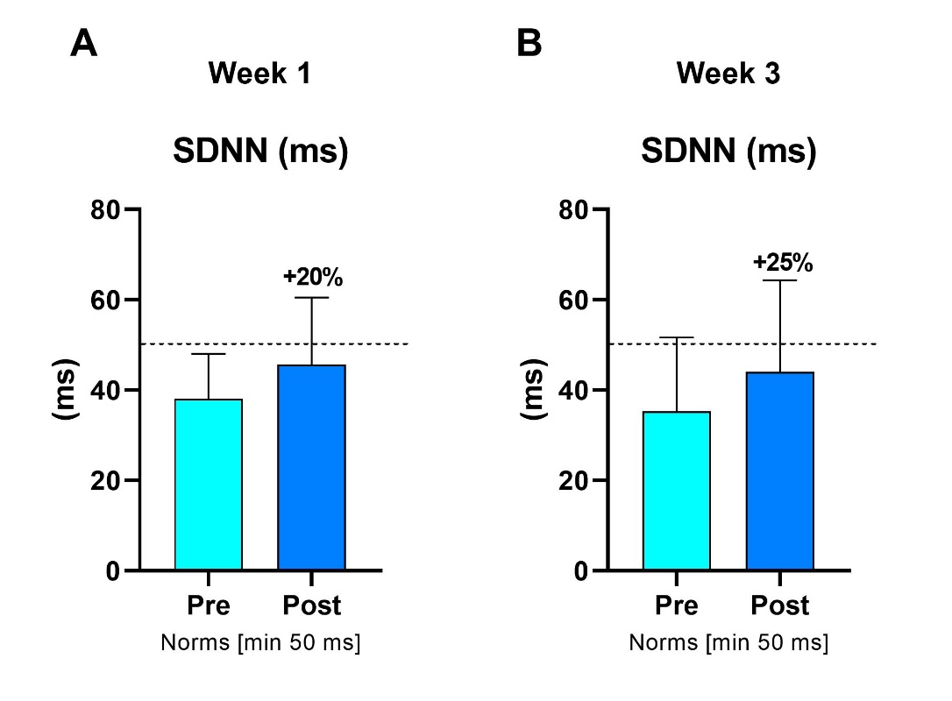

SDNN (ms), the standard deviation of normal-to-normal heartbeat intervals, measures heart rate variability. A higher SDNN indicates greater variability, which is often linked to better cardiovascular health and resilience to stress; conversely, a lower SDNN can indicate stress or underlying health issues.
The observed 20% increase in SDNN after 30 minutes of therapy in the first week and a 25% increase in the third week demonstrate that the therapy significantly improved heart rate variability. This improvement suggests enhanced cardiovascular health, increased stress resilience, and better recovery over time.

High-frequency (HF) power domain in heart rate variability
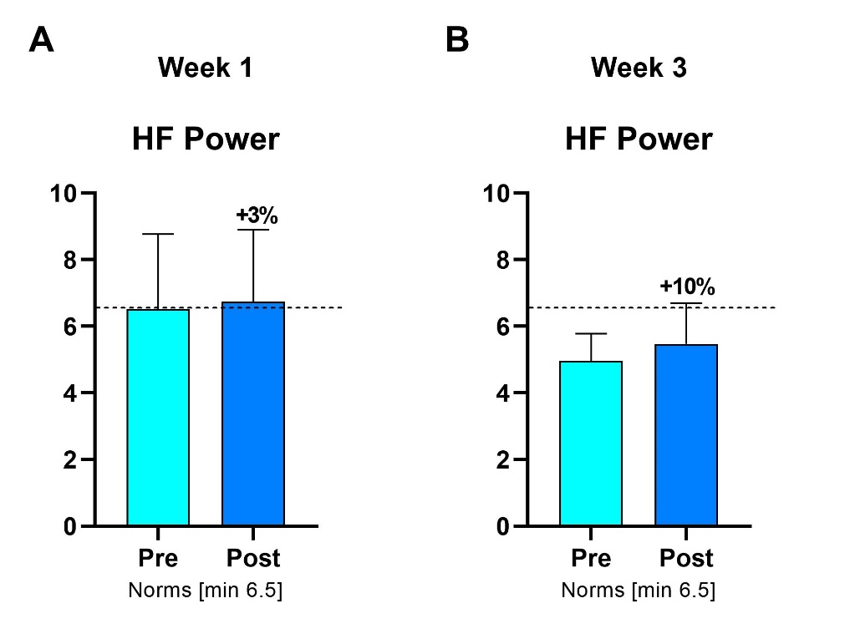
The high-frequency (HF) power domain in heart rate variability is indicative of parasympathetic nervous system activity.
A 3% increase in HF power after 30 minutes of therapy in the first week, followed by a 10% increase in the third week, indicates that the therapy progressively enhanced parasympathetic activity. This suggests an improvement in the body's relaxation and recovery responses over time.

Cerebral Blood Flow (CBF) to the Pre-Frontal Cortex

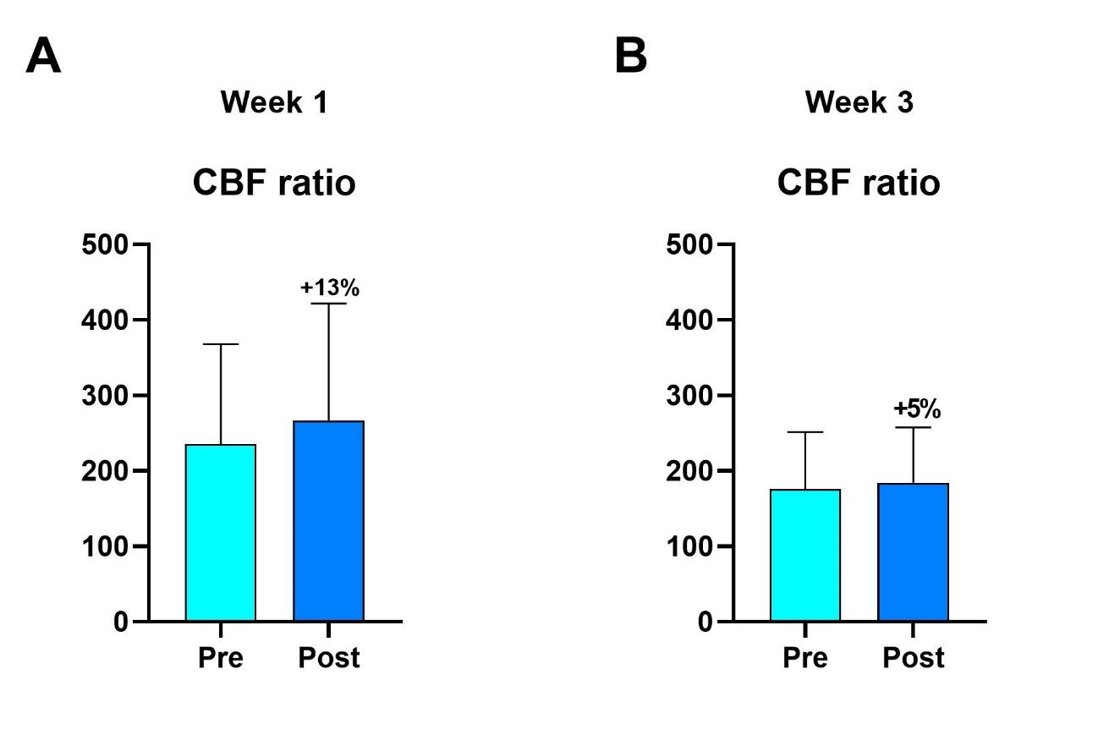
This parameter measures the cerebral blood flow to the Pre-Frontal Cortex.
An increase of 13% in cerebral flow after 30 minutes of therapy in the first week, followed by a 5% increase in the third week, indicates that the therapy effectively enhances blood flow to this area. This increased blood flow improves cell oxygenation and nutrition in the Pre-Frontal Cortex, suggesting beneficial effects on brain function.

Phase Angle
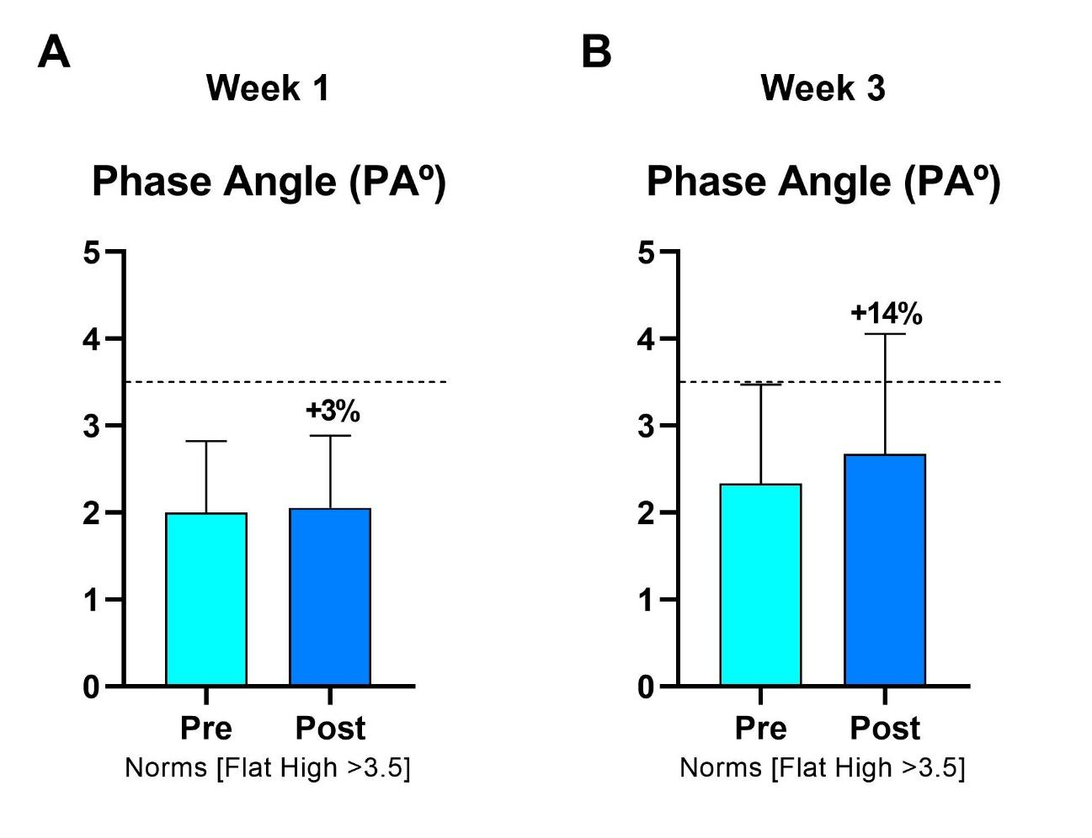
The Phase Angle reflects the relationship between resistance and capacitive reactance. A very low Phase Angle indicates poor integrity of cell membranes, while a high Phase Angle suggests well-preserved membranes and good cellular mass.
An increase of 3% in the Phase Angle after 30 minutes of therapy in the first week, followed by a 14% increase in the third week, demonstrates that the therapy effectively improves cell membrane integrity and cell mass over time.

Depression Anxiety and Stress Scale 21 - DASS-21
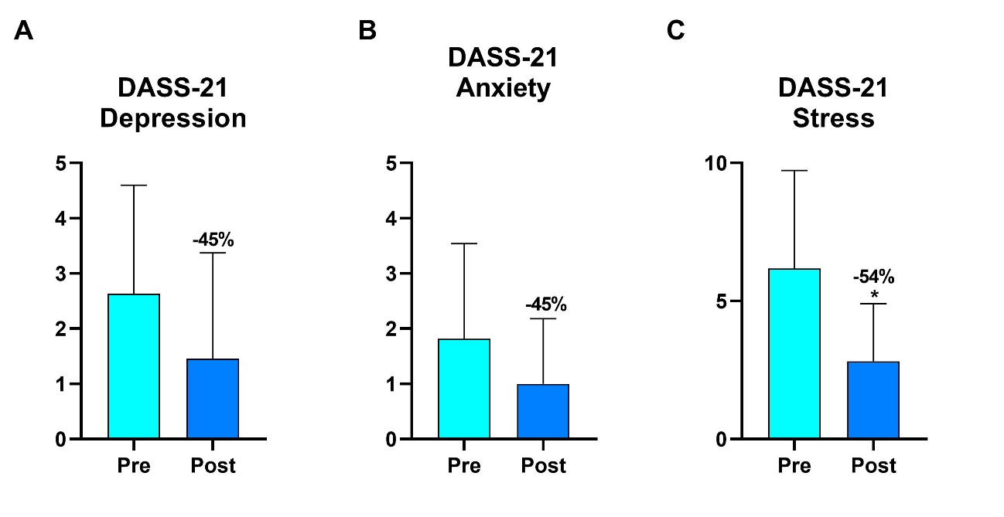
The Depression Anxiety and Stress Scale 21 (DASS-21) is designed to assess the levels of depression, anxiety, and stress-related feelings in individuals, with higher scores indicating more severe thoughts and feelings.
The results indicate a significant improvement after three weeks of treatment, with a 45% reduction in depression scores, a 45% reduction in anxiety scores, and a 54% reduction in stress levels. This demonstrates the treatment's effectiveness in alleviating these feelings.
The * symbol shows that there was a statistically significant difference between both evaluations.

Medically Unexplained Symptoms - MUS
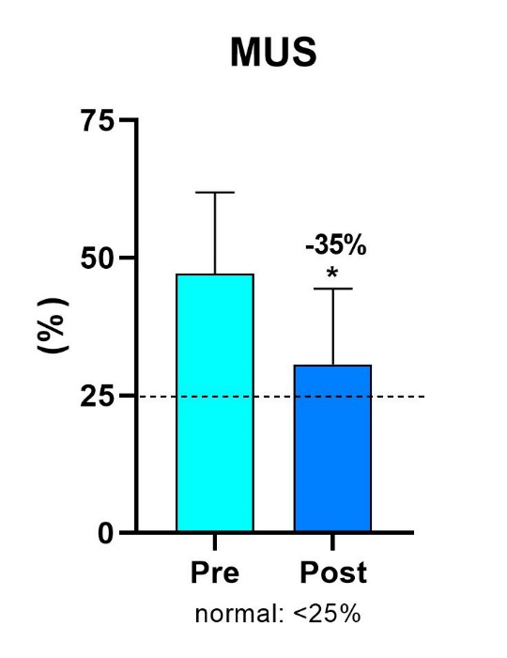
The percentage of Medically Unexplained Symptoms (MUS) was measured before the treatment in the first week and again after three weeks of treatment. Typically, normal values are found below 25%.
After three weeks of therapy, there was a 35% reduction in MUS, bringing them nearly down to normal levels.
The * symbol shows that there was a statistically significant difference between both evaluations.

Pittsburgh Sleep Quality Index - PQSI
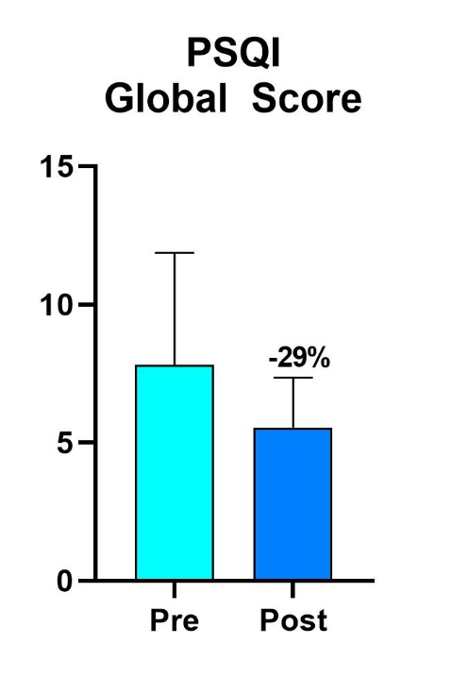

The Pittsburgh Sleep Quality Index (PSQI) questionnaire evaluates various factors affecting sleep quality, including subjective sleep quality, sleep latency, sleep duration, sleep efficiency, sleep disturbances, use of sleep medication, and daytime dysfunction. On this scale, higher scores indicate poorer sleep quality, which is summarized in a Global Score.
After three weeks of therapy, there was a 29% improvement in overall sleep quality, reflecting significant enhancements across these dimensions.

General Wellness Questions
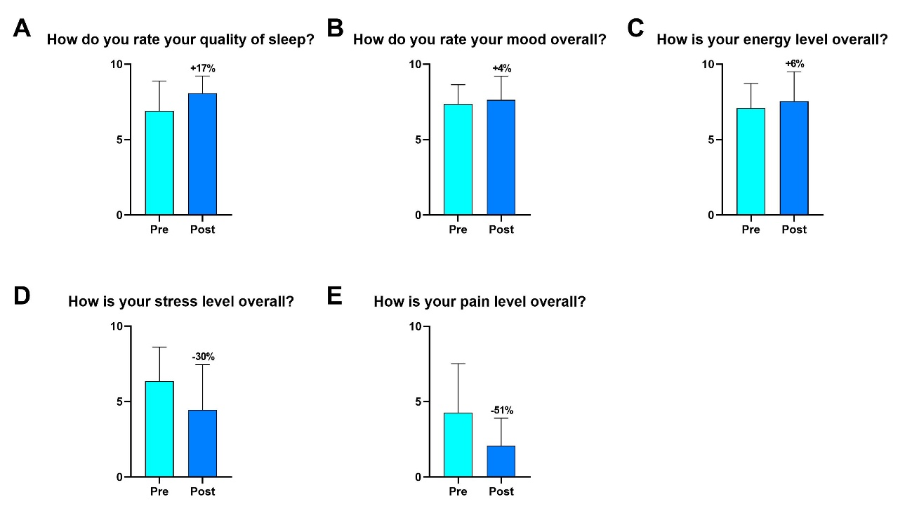

Participants provided subjective responses to general questions concerning their overall health.
After three weeks of therapy, the results showed notable improvements: sleep quality increased by 17%, mood improved by 4%, and energy levels rose by 6%. Additionally, there was a 30% reduction in stress levels and a 51% decrease in reported pain (discomfort). These outcomes underscore the therapy's effectiveness in enhancing various aspects of health.

CONCLUSIONS

This pilot study presents compelling evidence of the multifaceted benefits of the therapy applied over a three-week period. Key findings include:
- Cardiovascular and Autonomic Regulation: There was a measurable decrease in Mean Heart Rate (HR) by up to 3%, suggesting a reduction in sympathetic nervous system activity. Simultaneously, improvements in heart rate variability, as indicated by a 25% increase in SDNN and up to a 10% increase in HF power, highlight enhanced cardiovascular health and increased parasympathetic activity.
- Cerebral and Cellular Health: The therapy significantly boosted cerebral blood flow to the Pre-Frontal Cortex by up to 13%, enhancing cell oxygenation and potentially improving cognitive functions. Additionally, increases in the Phase Angle by up to 14% reflect improvements in cellular integrity and mass.
- Psychological Well-being: The Depression Anxiety and Stress Scale 21 (DASS-21) results show a dramatic reduction in related feelings, with decreases of 45% in depression and anxiety and 54% in stress-related feelings, underscoring the therapy's potency in alleviating psychological distress.
- Sleep and General Wellness: The Pittsburgh Sleep Quality Index (PSQI) noted a 29% improvement in overall sleep quality. General wellness also improved significantly, with enhancements in mood, energy, and reductions in stress and pain.
- Reduction in Medically Unexplained Symptoms (MUS): There was a notable 35% reduction in MUS, aligning them closer to normal levels, which underscores the therapy's effectiveness in addressing symptoms that typically elude medical explanation.
Overall, this pilot study demonstrates that the therapy not only significantly impacts specific physiological and psychological parameters but also contributes broadly to enhancing overall well-being. These results suggest that further investigation with a larger cohort over an extended period could be beneficial to confirm these findings and explore long-term benefits and mechanisms.

